Practical 1

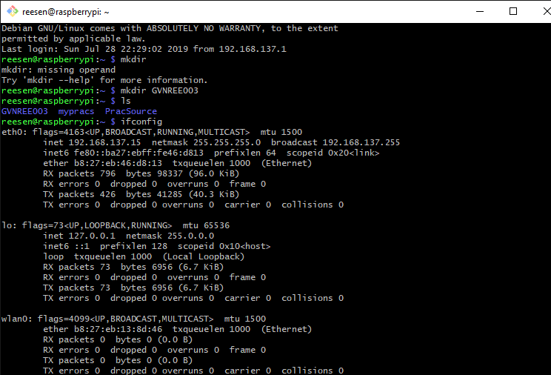GVNREE003

Figure 1: Output after running the $ ls command

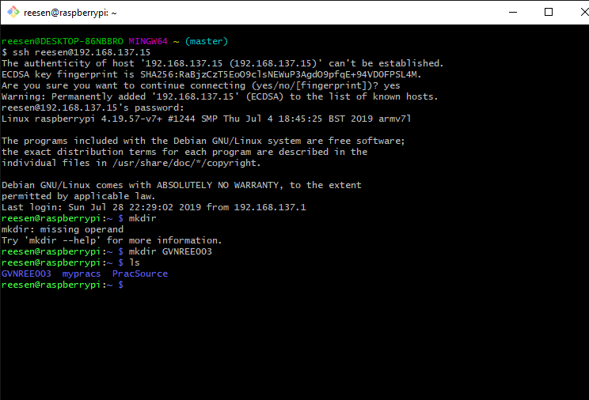

Figure 2: Output after running the $ ifconfig command

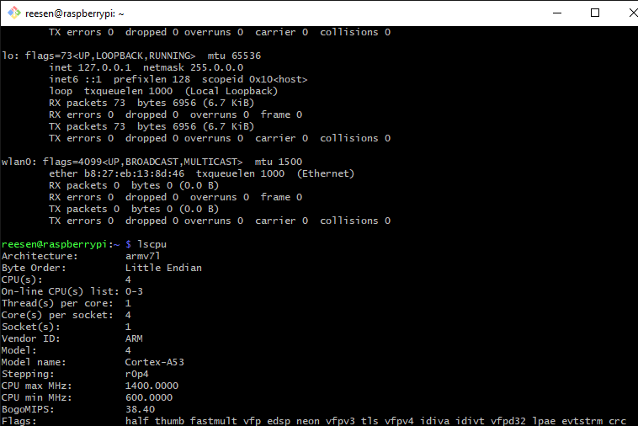

Figure 3: Output after running the $ lscpu command

GitHub repository: <https://github.com/Reesen552/EEE3096S>